[**munotes.in**](http://munotes.in/)**PRACTICAL 6**

**Aim:Configuring UDP and TCP**

**1] Click server/ Desktop/IP Configuration /Static [http client]:-**

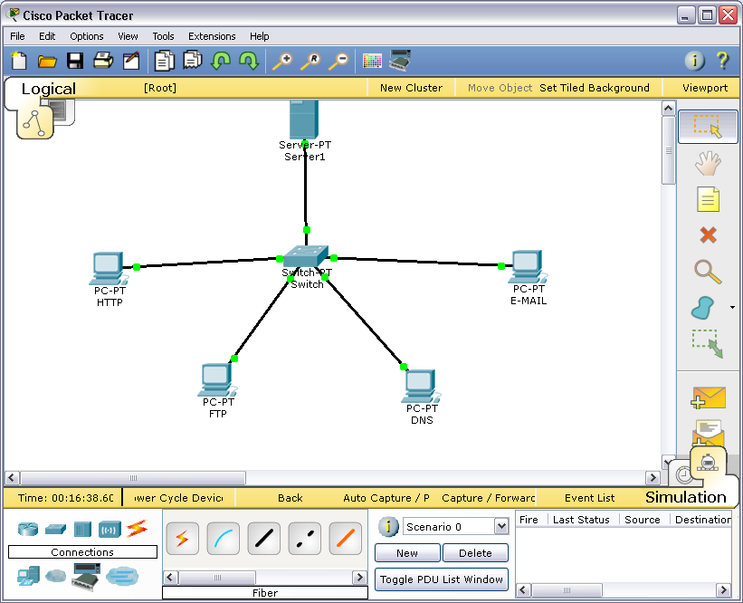

**2] Click PC0/ Desktop/IP Configuration /Static [multiserver]:-**

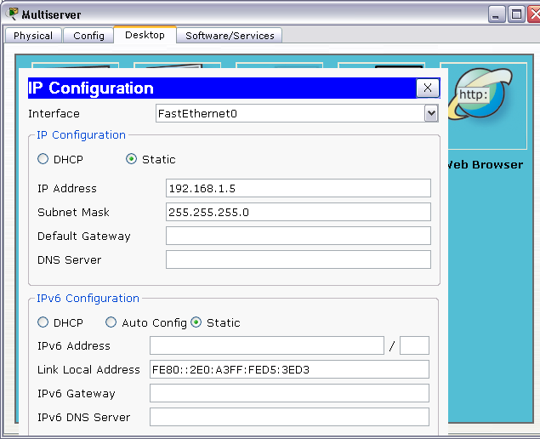

**3] Click PC0/ Desktop/IP Configuration /Static [http client]:-**

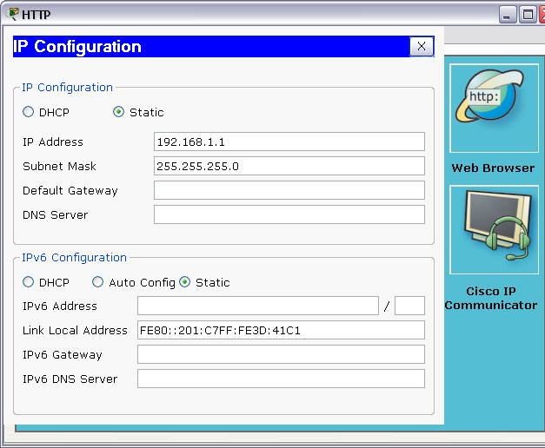

**4] Click PC1/ Desktop/IP Configuration /Static [ftp client]:-**

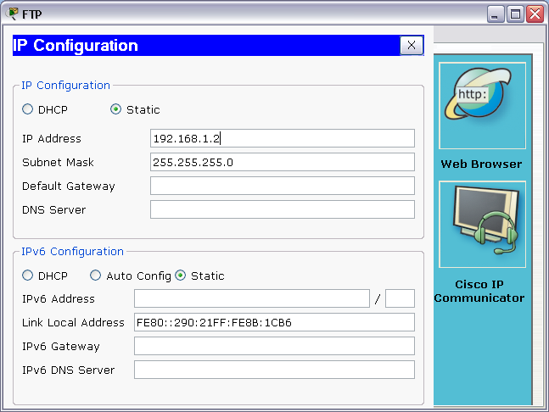

**5] Click PC2/ Desktop/IP Configuration /Static [dns client]:-**

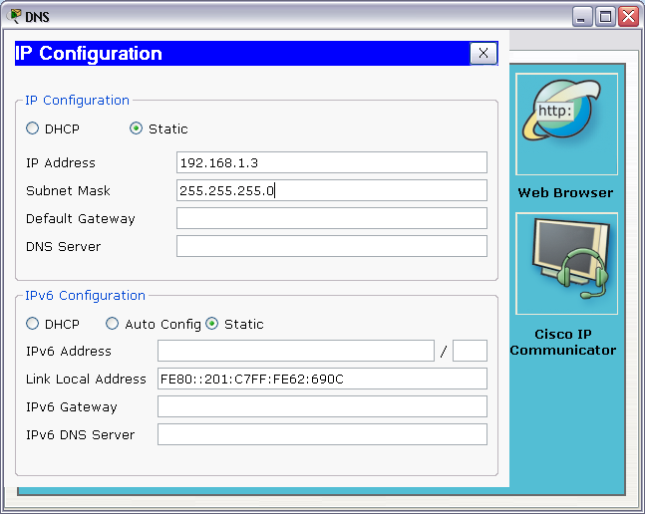

**6] Click PC3/ Desktop/IP Configuration /Static [Email client]:-**

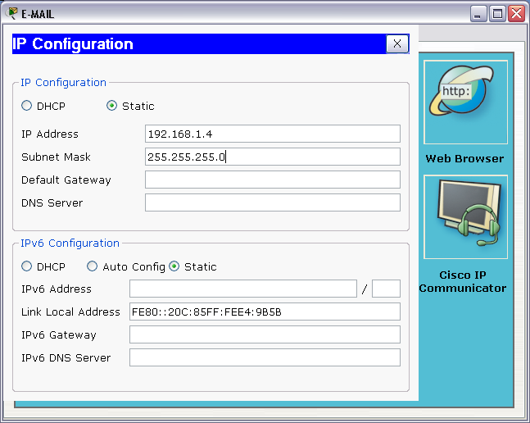

**7] Command prompt for multiserver:-**

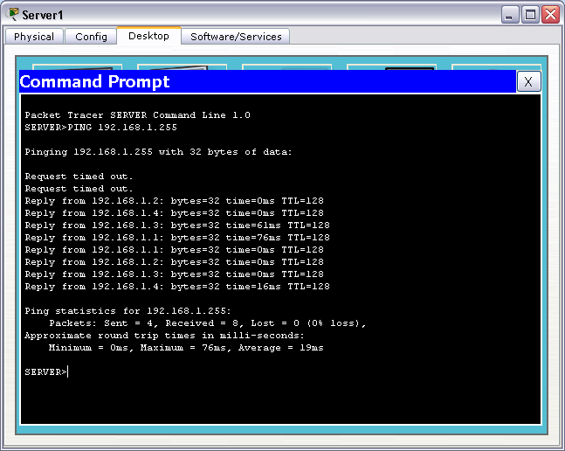

**8] Command prompt for http client:-**

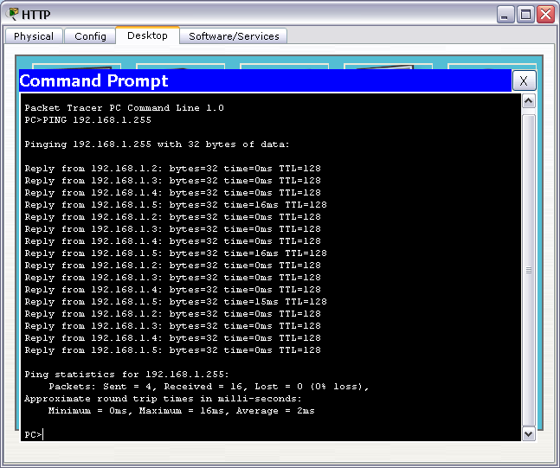

**9] Command prompt for ftp client:-**

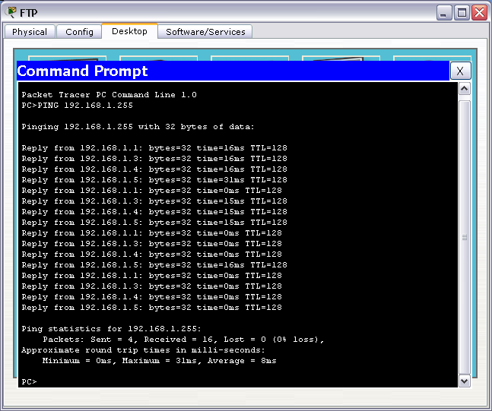

**10] Command prompt for dns client:-**

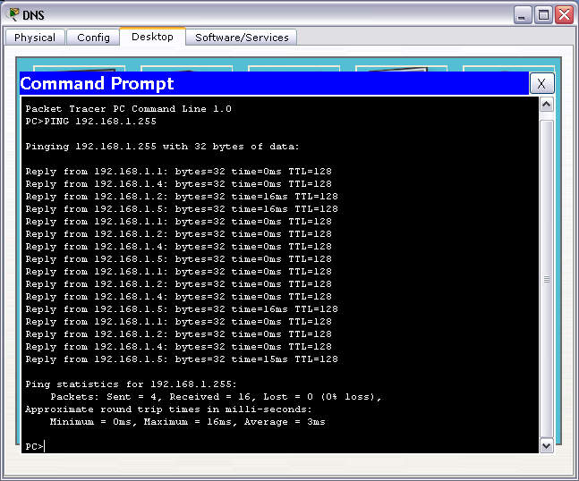

**11] Command prompt for Email client:-**

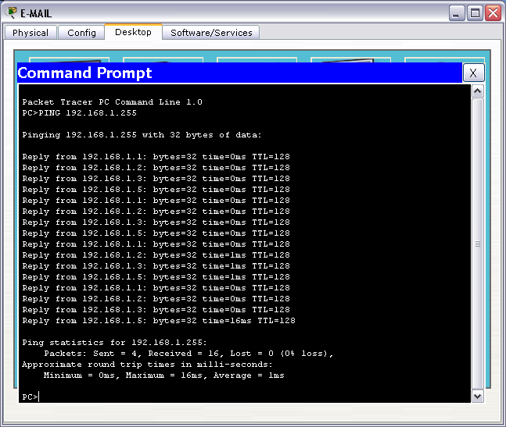

**12]** **Go to simulation mode->click on http->click on web browser->type ip address192.168.1.5 ->Go**

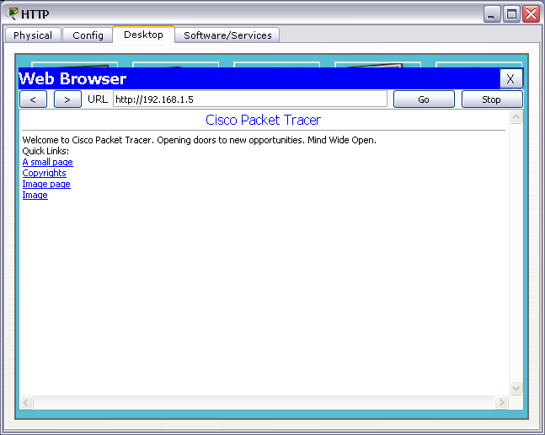

**13] Go to realtime mode->click on multiserver->desktop->config->dns**

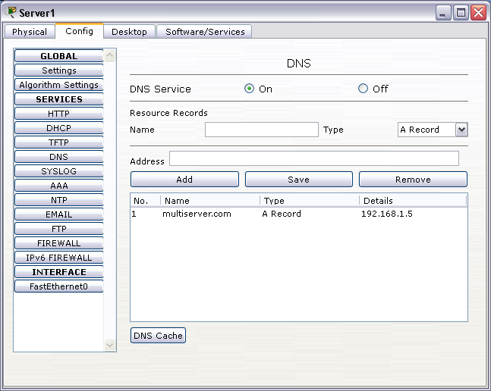

**14] Go to realtime mode->click on multiserver->desktop->config->email**

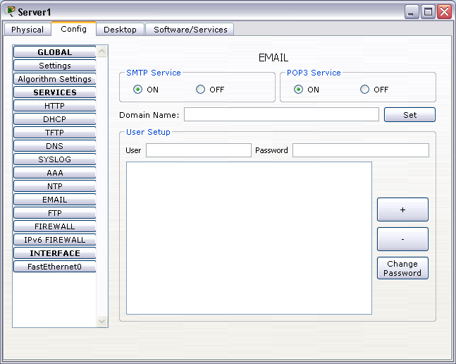

**15] Open simulation mode:-**

**16] http click->desktop->web browser->type ip address 192.168.1.5-> then go**

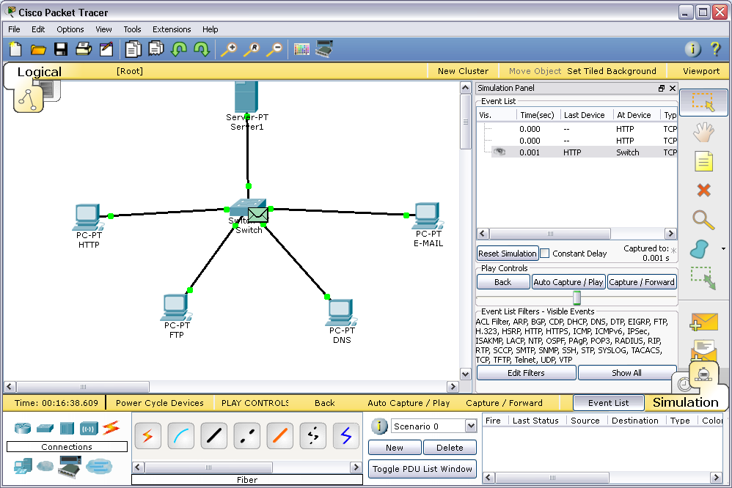

**17] Click ftp client->command prompt ->Type >ftp 192.168.1.5**

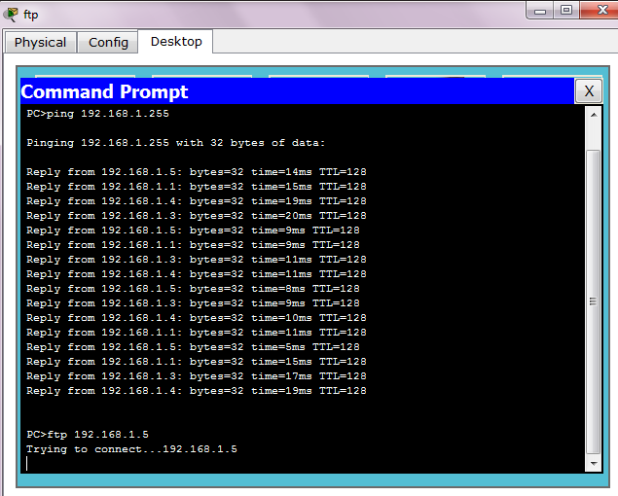

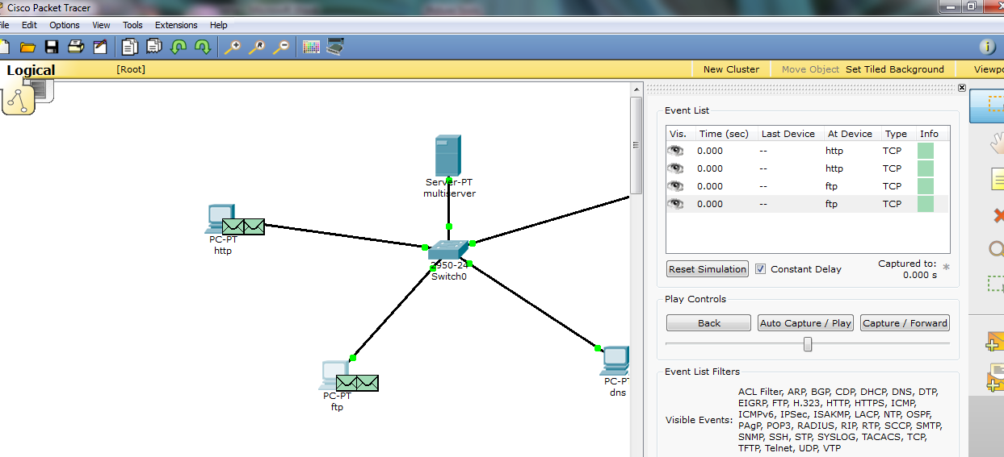

**18] Click dns-> desktop-> command prompt ->Type-> nslookup 192.168.1.5**

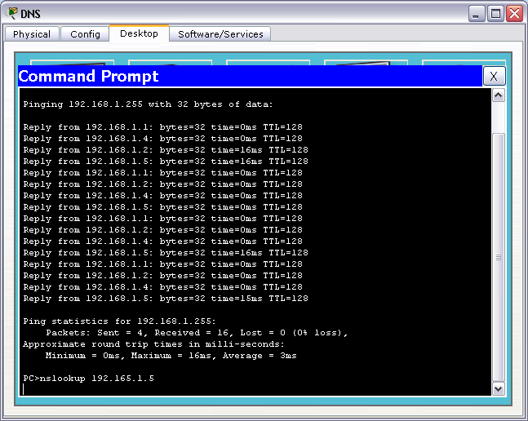

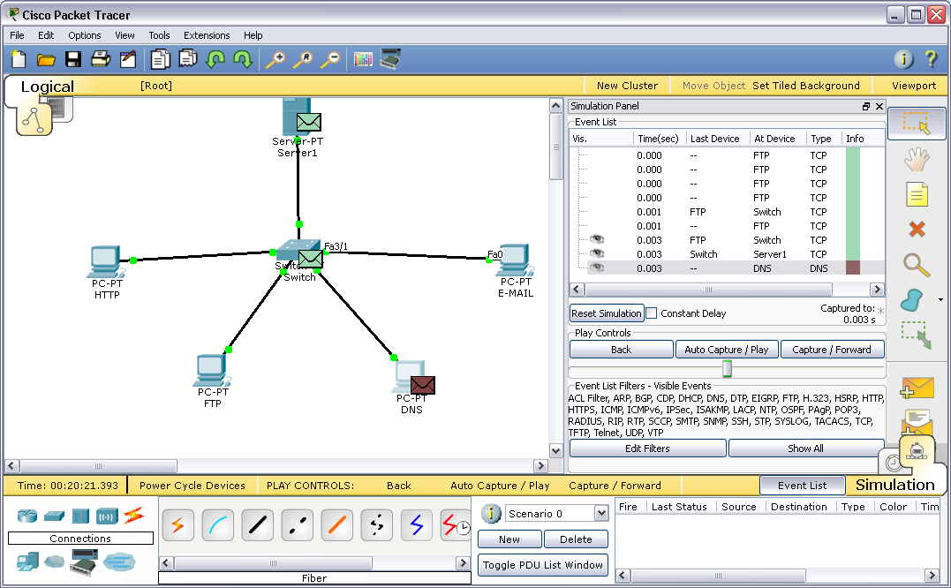

**19] Click on email-> desktop-> email -> configure email**

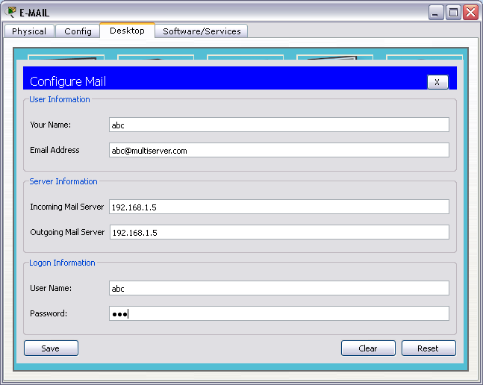

**20] Go to compose mail**

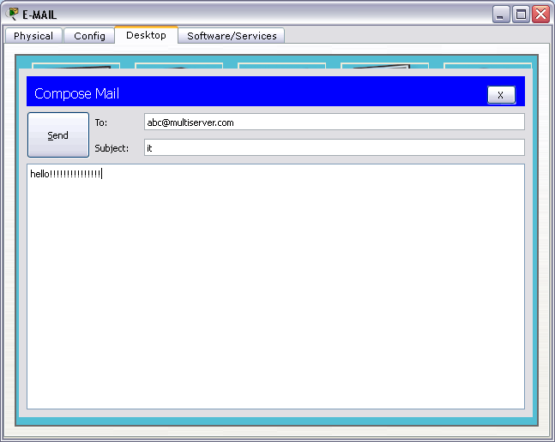

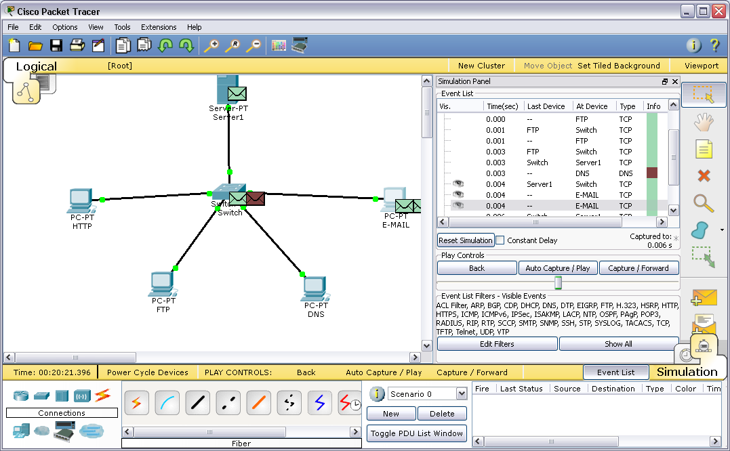

**21] Go to simulation mode -> Click on capture and forward ->then click again capture and forward**

**A] http client:-**

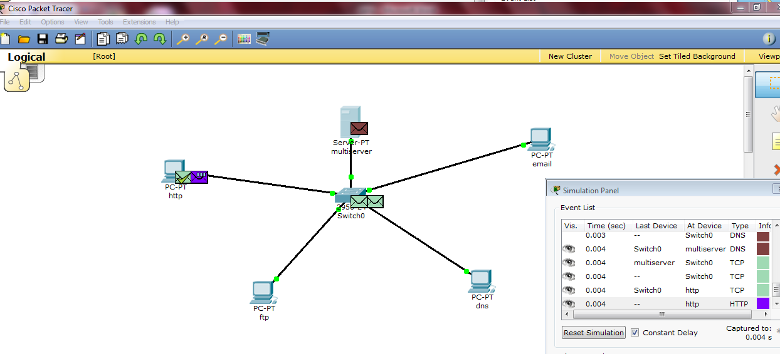

**B] ftp client:-**

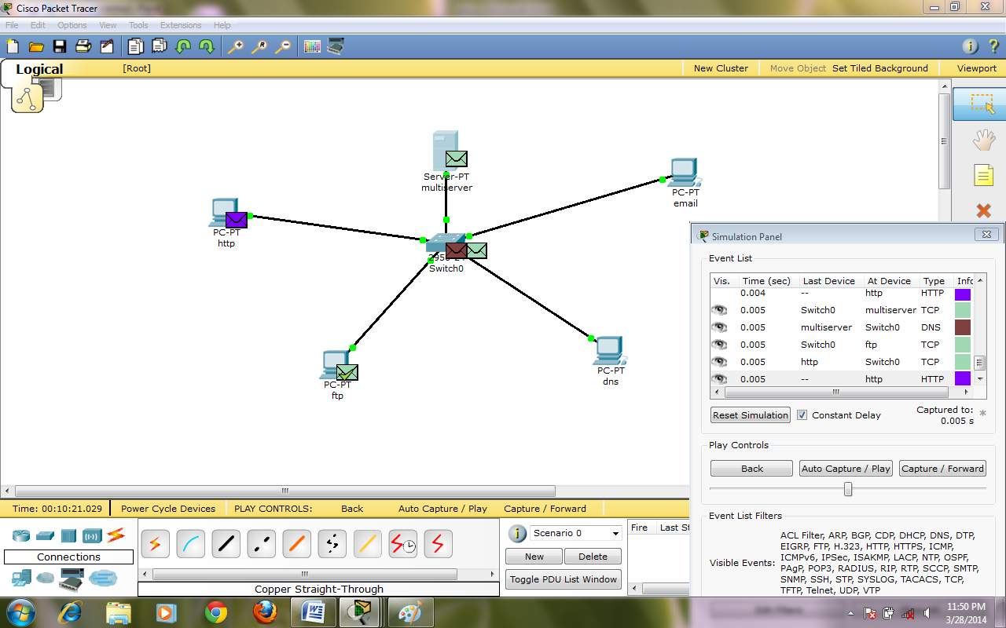

**C] Dns client:-**

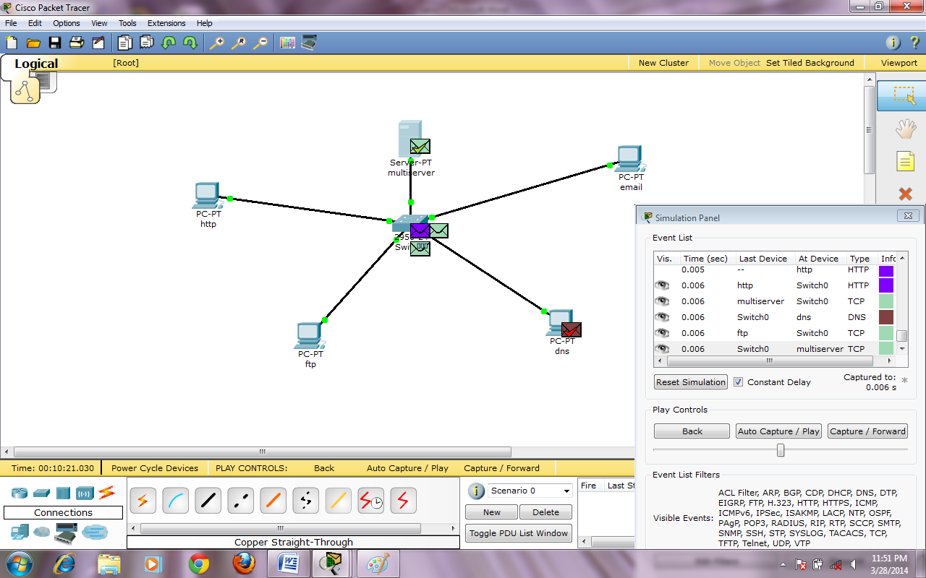

**D] Email client:-**

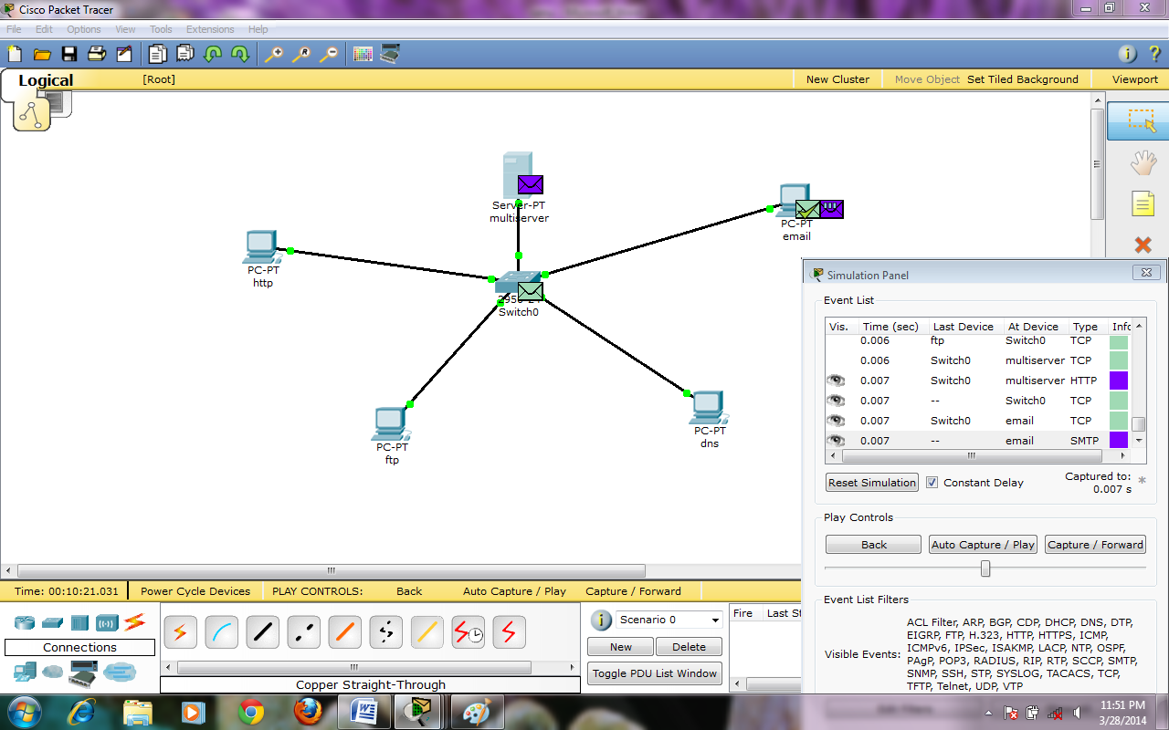

**22] Now Edit filter -> unchecked the checkbox show all ->select http,tcp->capture and forward**

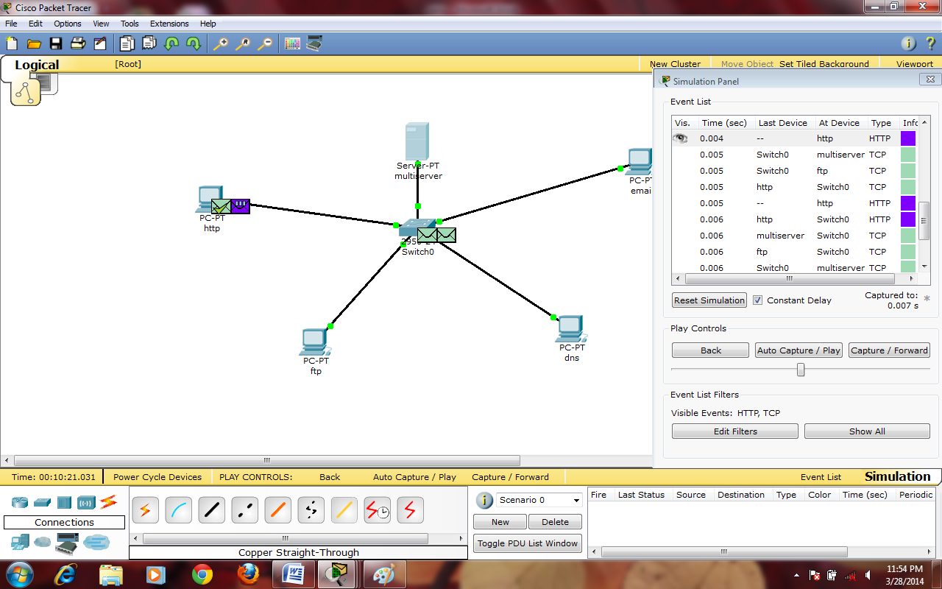

**23] click on inbound PDU details**

**A] http:-**

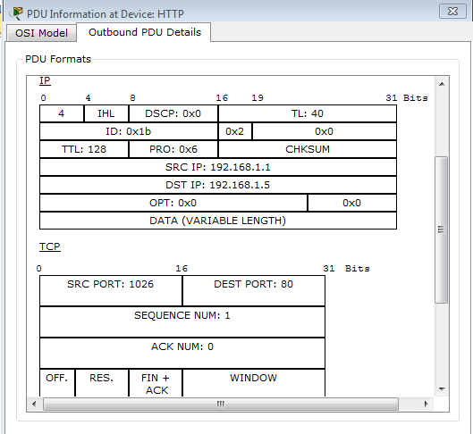

**24] Edit filter -> unchecked the checkbox show all ->select ftp,tcp->capture and forward**

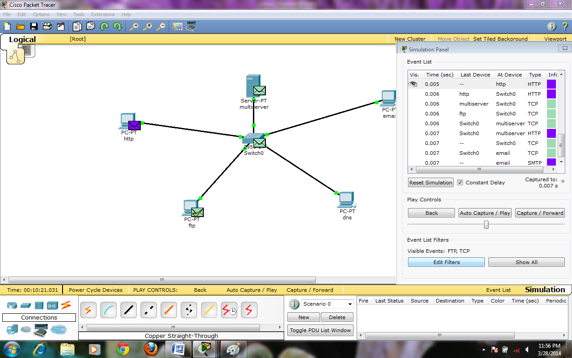

**23] click on inbound PDU details**

**B] Ftp:-**

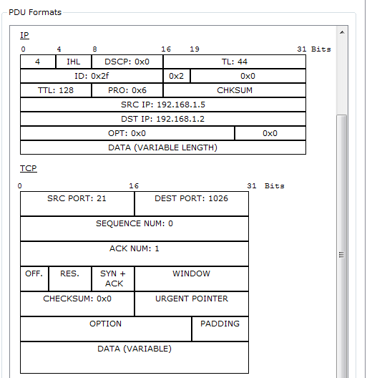

**25] Edit filter -> unchecked the checkbox show all ->select udp,dns->capture and forward**

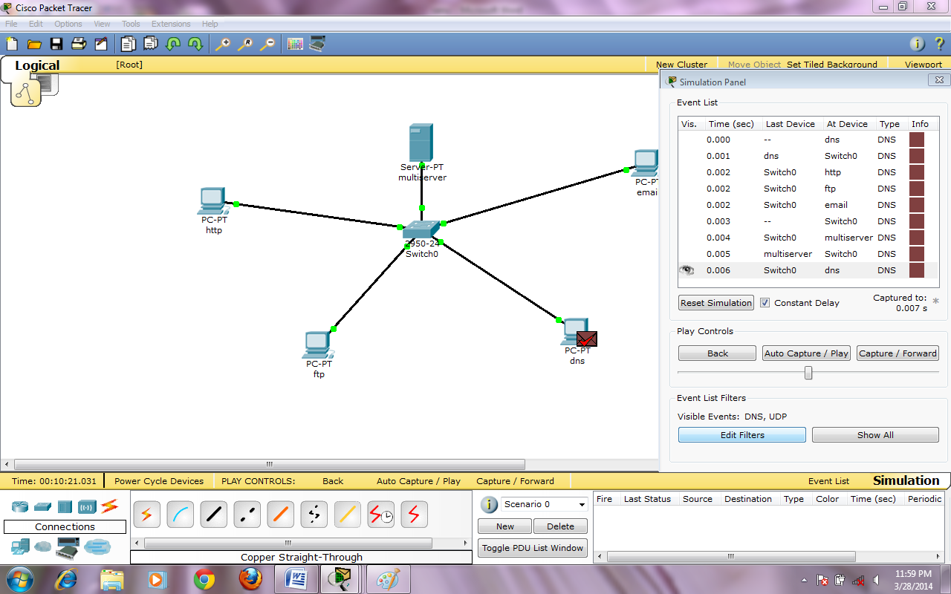

**26] click on inbound PDU details**

**C] Dns:-**

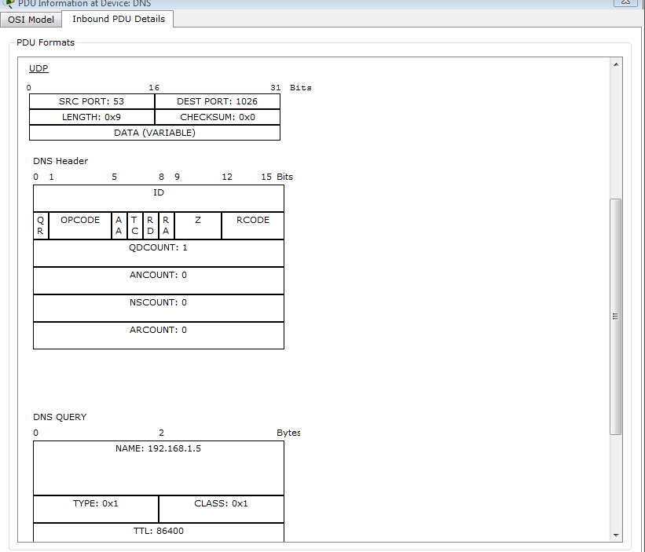

**27] Edit filter -> unchecked the checkbox show all ->select pop3,smtp,tcp->capture and forward**

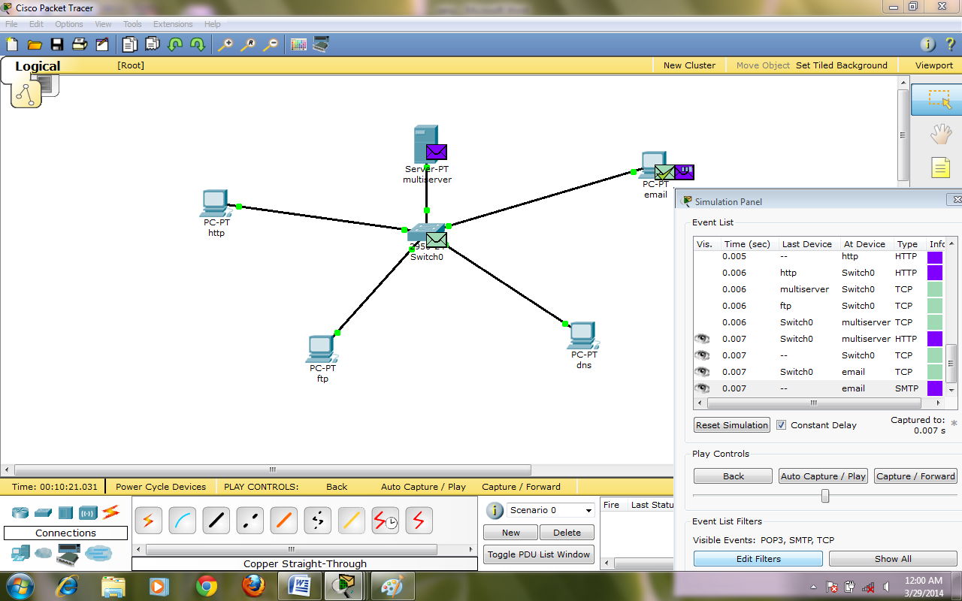

**28] click on inbound PDU details**

**B] Email:-**

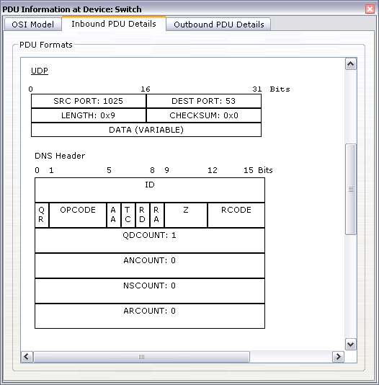

Practical –

**Aim : Configure SMTP, POP3, IMAP and MIME.**

**Step 1: Go to Control Panel->Mail Setup->E-Mail Accounts**

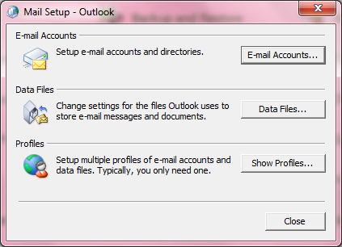

**Step 2: Enter Name , Email address and password -> next**

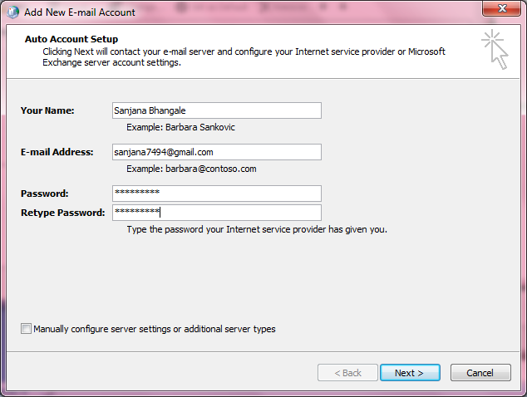

**Step 3: Finish**

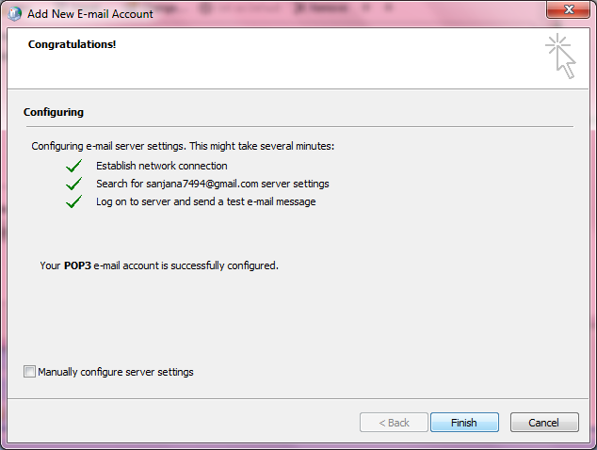

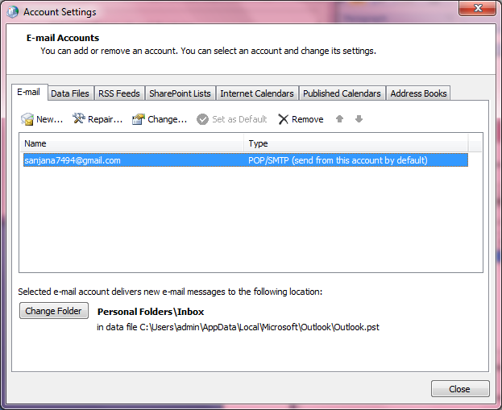

**Step 4: Open Microsoft Office Outlook**